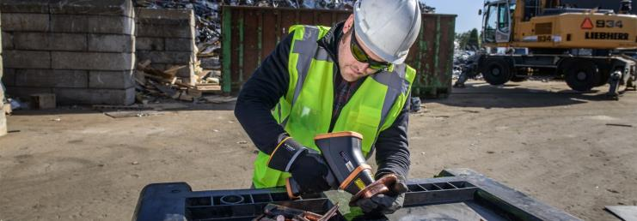
Key Features
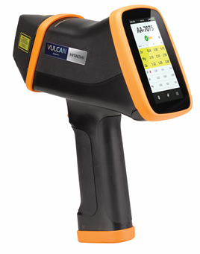  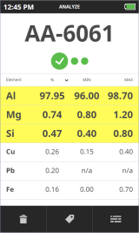 | Vulcan Expert+ – The fastest handheld alloy analyser for rapid and accurate alloy identification.  Laser Induced Breakdown Spectroscopy (LIBS) technology:  - No X-Rays – no expensive and time consuming training classes  - One second measurement for all alloys, all sample types - no exceptions  - No sensitive components in the analyser nose, no detector punctures  Just point and shoot:  - Custom user interface, based on extensive customer survey  - No calibrations to choose from - no chance for user error  - Fixed one second measurement time  Virtually non-destructive technology  - Hardly visible burn mark left on the sample surface  - Less than one billionth of a gram of material is consumed  Factory calibrated and ready to go  - Ready to use straight out of the box  - Calibrated in the factory with certified reference materials (CRMs) – traceable calibrations  - Automatic calibration selection  - Check sample (Al 7075) provided with the instrument to verify the instrument stability and performance  Built to last - fit for purpose  - Balanced, lightweight design (1.5 kg with the battery)  - Rugged: IP54 (NEMA 3 equivalent), dust and splash water proof  - MIL-STD-810G compliant – drop and vibration tested  - Measurement optics protected with sapphire glass  - Display protected by 3 mm thick scratch and impact resistant Dragontrail™ glass  - Full day operation with one battery (up to 8-10 hours). Two batteries included  Peace of mind  - 3 year warranty for the Vulcan Expert+ instrument  - 3 months warranty for batteries  - Extended warranty plans available

Performance
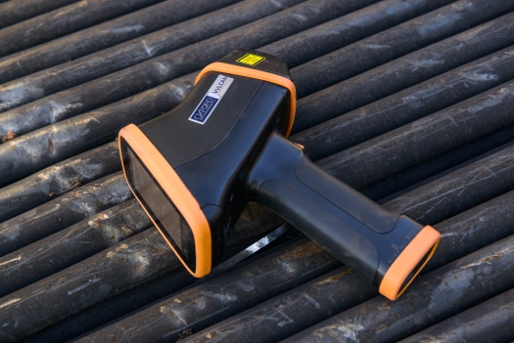 |  | - Identify hundreds of alloy grades in just one second. Including irons, low alloy steels, tool steels, stainless steels, Al, Mg, Cu, Co, Pb, Sn, Ti, Ni alloys.  - Pre-loaded AISI, DIN and JIS grade libraries  - User customisable grade libraries  - Identification of pure elements: Ag, Au, Bi, Cd, Cr, Ge, Hf, In, Mn, Mo, Nb, Pd, Pt, Sb, Si, Ta, V, W, Y and Zr  - Analyse large or small samples  - Adjustable pre-burn function to clean the sample surface before making the measurement  - No calibrations to choose from. The instrument automatically detects the sample type and selects the right calibration eliminating the chance of user error  - Typical detection limits between 0.02 % and 0.1% depending on the element and matrix  - Operating temperature range 0 – 40 ⁰C (32 – 104 F), non-condensing
Intuitive user interface
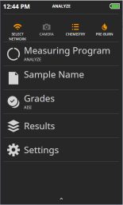 | - Integrated computer with Linux operating system for unparalleled reliability  - Large 4.3” capacitive touch screen protected with 3 mm thick Dragontrail™ scratch and impact resistant glass  - Display can be operated with gloves on  - Simplified and intuitive user interface, available in 16 languages  - Point and shoot operation, minimal training required  - Large grade ID display with up to 3 closest matches  - Pin and highlight the important elements for even better visibility  - User customisable measurement programs including Analyse, Pass/Fail and Average options  - Smart sample tags for quick notes, lot numbers, purchase order information and more  - Optional built-in close focus CCD camera to help targeting the instrument  - Instrument stores up to 30 000 results with camera images  - Customisable CSV reporting directly from the analyser to a USB flash drive  - Connectivity to EXTOPE cloud service via Wi-Fi or mobile phone  - User interface available in 16 languages: Czech, Chinese traditional, Chinese simplified, Dutch, English, Finnish, French, German, Italian, Japanese, Korean, Polish, Portuguese, Russian, Spanish, Swedish
Vulcan EXPERT+ package contents
Vulcan Expert+ analyser
Laser safety goggles
Vulcan Expert+ quick start guide
Full Vulcan user manual provided in 7 languages English, Chinese (simplified), French, German, Japanese, Russian and Spanish (electronic, stored on the USB memory stick).
Grade libraries: AISI, DIN, GB, JIS (user selectable and editable)
Calibration set (Al, Co, Cu, Pb, Mg, Ni, Sn, Ti, Zn, stainless steels, low alloy and tool steels)
Pure element identification for Ag, Au, Bi, Cd, Cr, Ge, Hf, In, Mn, Mo, Nb, Pd, Pt, Sb, Si, Ta, V, W, Y and Zr
Li-ion battery 7.2 V / 6.2 Ah, (2 pcs)
Battery charger
Power supply with changeable power plugs (US/Japan, Europe, UK, Australia)
Carry case for transport and storage of the Vulcan Expert analyser
Lanyard and wrist strap
Nose opening tool
Cleaning kit – pack of 100 optical grade cotton buds to clean the measurement window
USB memory stick (contains electronic copies of the Vulcan series user manuals and quick guides)
Aluminium 7075 check sample
Calibration folder

